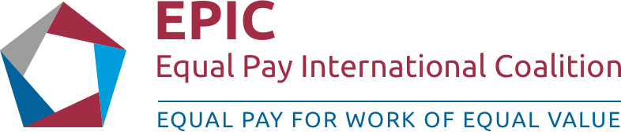


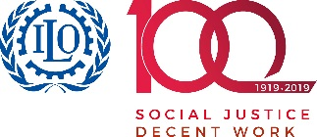
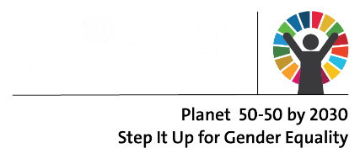
THE REGIONAL FORUM ON SUSTAINABLE DEVELOPMENT FOR THE UNECE REGION
Equal pay for work of equal value
Concept Note for the Side Event
Date: 22 March 2019, 13:15-15:00

Background:
The Regional Forum on Sustainable Development (RFSD), to be held on 21-22 March 2019 in Geneva, follows up on and reviews the implementation of the 2030 Agenda and its Sustainable Development Goals (SDGs) in the UNECE region. The meeting will focus on the sub-set of SDGs to be reviewed at the 2019 session of the High-level Political Forum on Sustainable Development (HLPF 2019): SDG 4 (quality education), SDG 8 (decent work and economic growth), SDG 10 (reduced inequalities), SDG 13 (climate action), and SDG 16 (peace, justice and strong institutions).
SDG 8 promotes sustained, inclusive and sustainable economic growth, full and productive employment and decent work for all women and men, including for young people and persons with disabilities. Equal pay for women and men for work of equal value is central to realizing gender equality and women's economic empowerment, reducing poverty and is beneficial to promote economic growth. To sustain SDG 8, there is the necessity to acknowledge the central role played by gender equality (SDG 5) in having a multiplier effect on the accomplishment of all the SDGs, including SDG 8. Therefore, UN Women, ILO and OECD joined forces to accelerate progress towards SDG target 8.5 by leveraging expertise across a diverse range of stakeholders through concrete actions on the ground and in workplaces.
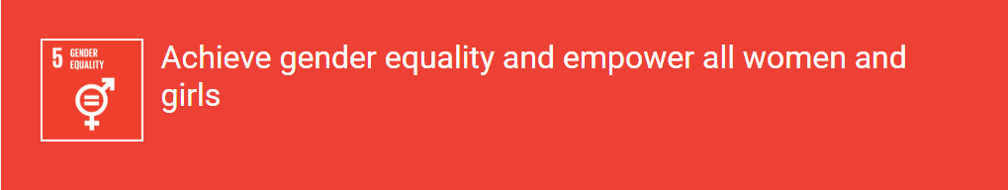

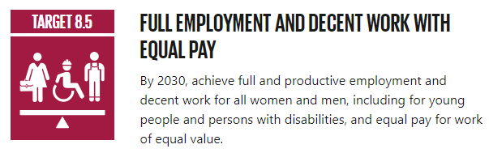

The ILO-Gallup world survey Towards a Better Future for Women and Work: Voices of Women and Men shows that across the world, women want to be in paid jobs. It also shows that one of the main challenges for women at work is unequal pay. Across all regions, countries and sectors, women are paid less than men. According to the ILO Global Wage Report 2018-2019, covering some 70 countries and about 80 per cent of wage employees worldwide, globally women continue to be paid approximately 20% less than men. Many countries in the Europe and Central Asia region (ECA) today experience gaps between men and women in labor force participation and pay. The participation gap is especially high in Turkey (42%) and in the Western Balkans (22%). Women’s participation rates for ages 15–64 range from a low of 16% in Kosovo to a high of 86% among working-age women in Belarus. Women make up slightly less than half the labor force in the region, and they earn on average 30% less than men.
The extent of the gender wage gap varies greatly within the ECA region. The differences across countries are large. Some countries (the EU10, Moldova, Turkey, the western Balkans, with the exception of Albania) have a gender wage gap of about 20%, putting them in a similar or better position than the United States. Other countries have gaps that are among the highest in the world (Tajikistan, with a gap of about 65%), while still others (Albania) have gaps in an intermediate range, about 35%. Moreover, women with the same educational qualifications as their men counterparts earn 25%.
The gender pay gap is symptomatic of the many challenges, including discrimination, that women face before entering the labour market and throughout their working lives, and that make them more vulnerable to poverty. Only about a third of the gender wage gap can be explained by high occupational segregation. Women may be self-selecting into less well-paying jobs or occupations that have favorable characteristics such as work hours compatible with school hours, work flexibility, or favorable nonmonetary benefits. Women’s childbearing and relatively generous maternity leave benefits in the formal sector have costly long-term income effects for women in Europe and Central Asia.
Reducing inequality and promoting decent work for all women and men have been identified as key objectives in the 2030 Sustainable Development Agenda, adopted at the United Nations in 2015. In addition to SDGs 5 and 8, mentioned above, SDG 10 seeks to “reduce inequality within and among countries”, emphasizing income growth of the bottom 40% of the population, the elimination of discrimination, as well as the adoption of policies, especially fiscal, wage and social protection policies, and progressively achieve greater equality.
Building on the recognition that no single actor can solve the challenge of achieving SDG 8.5 and 5 alone and that efforts can be accelerated through leveraging expertise across a diverse range of stakeholders, ILO, UN Women and the OECD joined forces and initiated the Equal Pay International Coalition (EPIC). Members of EPIC work together at the global, regional and national levels to support governments, employers and workers and their organizations, and other stakeholders, to make equal pay between women and men for work of equal value a reality, and reduce the gender pay gap.
Building upon the momentum gained since EPIC’s launch in September 2017, this high-level forum will launch EPIC in the ECA region and bring together regional leaders including governments, trade unions, private sector, and civil society to share knowledge, and exchange good practice on how to accelerate the achievement of equal pay for work of equal value.
Objective:
The suggested Side Event aims to:
- Discuss the equal access to decent work in the ECA region with a focus on pay related issues in line with the SDG target 8.5 – progress in the selected countries and planned measures;
- Jointly advocate for promotion of equal pay for work of equal value in ECA region;
- Launch EPIC in the ECA region;
- Support partners in the selected countries to take commitments/pledges and become EPIC members.

Title of the session: | “Equal pay for work of equal value”
Organizers: | ILO, UN Women, OECD, 2 government partners
Format: | The session will consist of brief presentations by invited panelists, followed by question and answer session.
Date and Time: | 22 March 2019 (TBC)
Venue: | International Conference Centre Geneva (CICG), Meeting room: TBD
Time: | 13:15-15:00 (TBC)
Language: | English
Co-moderators: | Ms. Alia El-Yassir, Regional Director, UN Women Regional Office for Europe and Central Asia  ________________, ILO  ________________, OECD

Provisional Agenda:
TBD
Participants:
Representatives of government entities including ministries responsible for labour and employment, ministries responsible for gender equality and national statistical offices, employers’ and workers’ organizations, relevant UN entities, the private sector, trade unions, gender advocates from the countries of ECA region (tentatively):
- Chair of Steering Committee: Switzerland
- Member of Steering Committee: Iceland
- Georgia
- Kazakhstan
- Turkey
Key speakers:
Names TBC

ILO-Gallup, Towards a Better Future for Women and Work: Voices of Women and Men, 2017.
http://www.worldbank.org/en/region/eca/brief/gender.
World bank, “Opportunities for Men and Women: Emerging Europe and Central Asia”, 2012, page 52. Available at - http://siteresources.worldbank.org/ECAEXT/Resources/258598-1322580725430/WB_genderReportFINAL.pdf
ILO, UN WOMEN AND OECD’S Vision for the Equal Pay International Coalition, page 3.
https://sustainabledevelopment.un.org/partnership/?p=26566.

